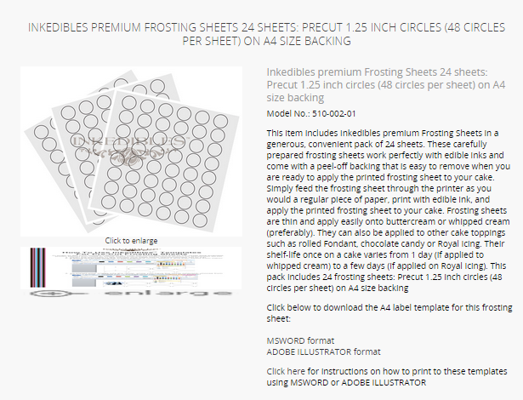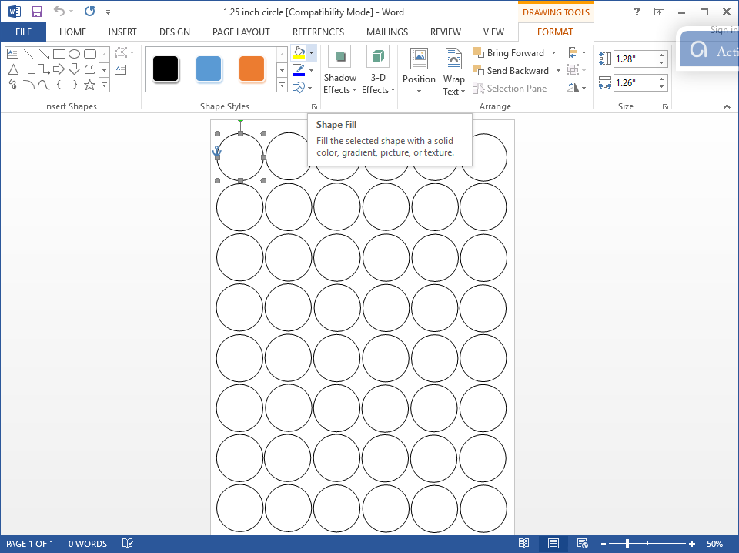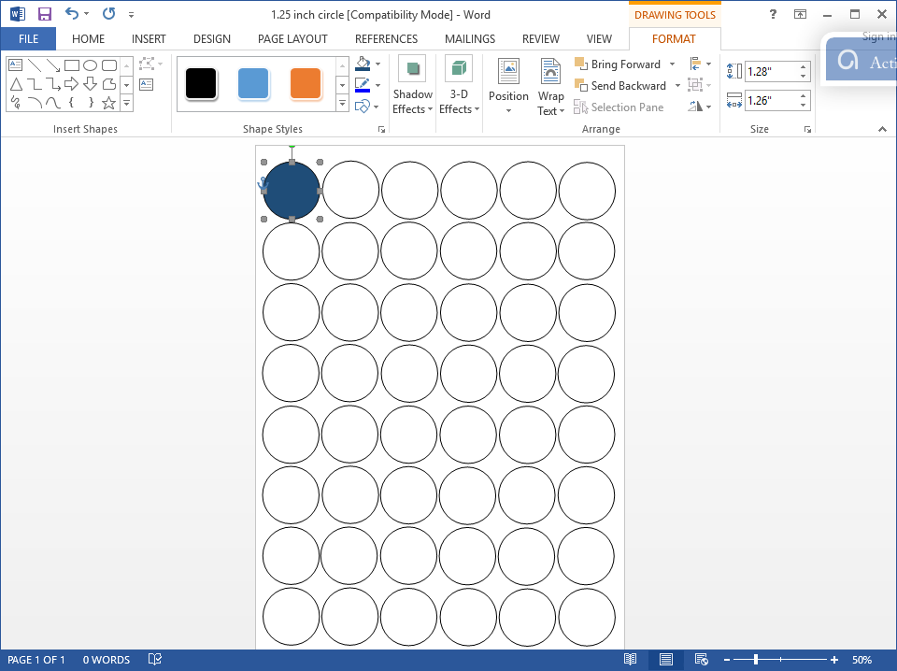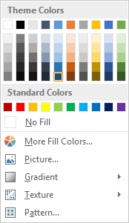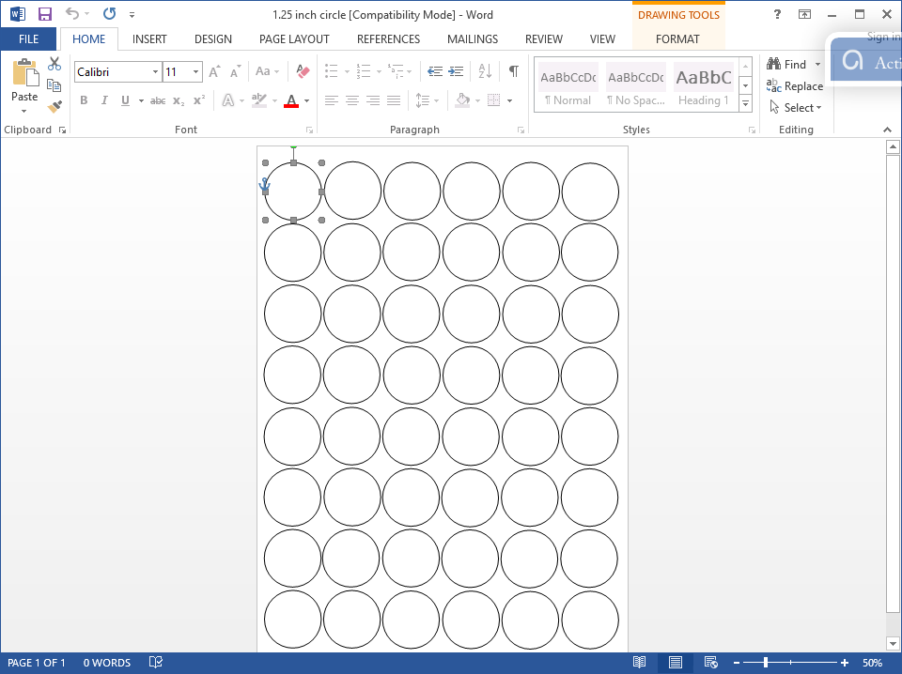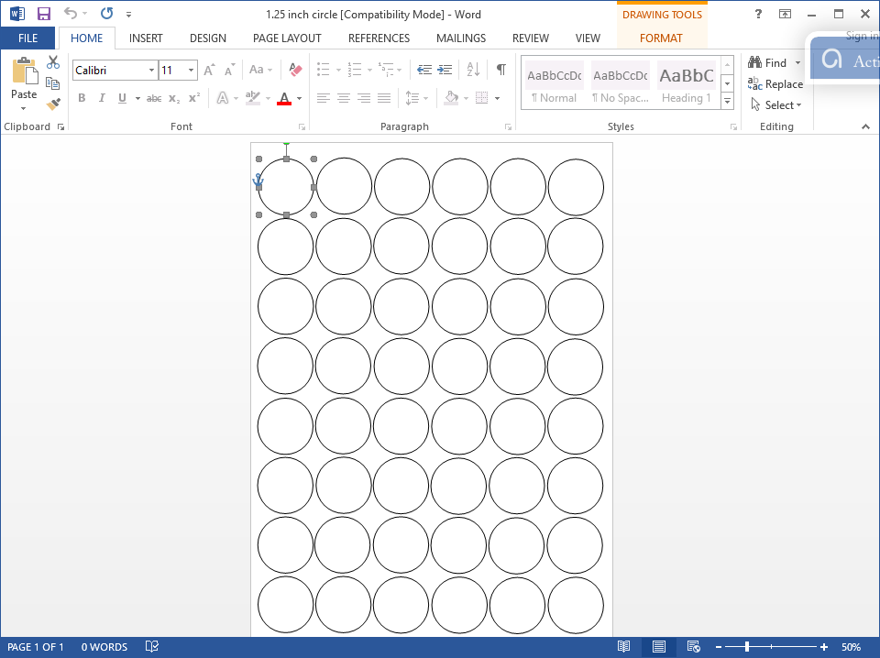

**Instructions on How to Use**

**Inkedibles**® **Premium/Artisan Frosting Sheet Circle/ Square Templates.**

1. First, download the template to print on frosting sheets from [www.inkedibles.com](http://www.inkedibles.com/) on the product page with your pre-cut frosting sheet size.

3. Click on [Format] page tab

6. Just repeat the process for all circle objects and print.

4. Click on [Shape Fill] drop down grid button.

5. From this menu you can change the color of object or input a picture.

2. Click on [Circle Object]