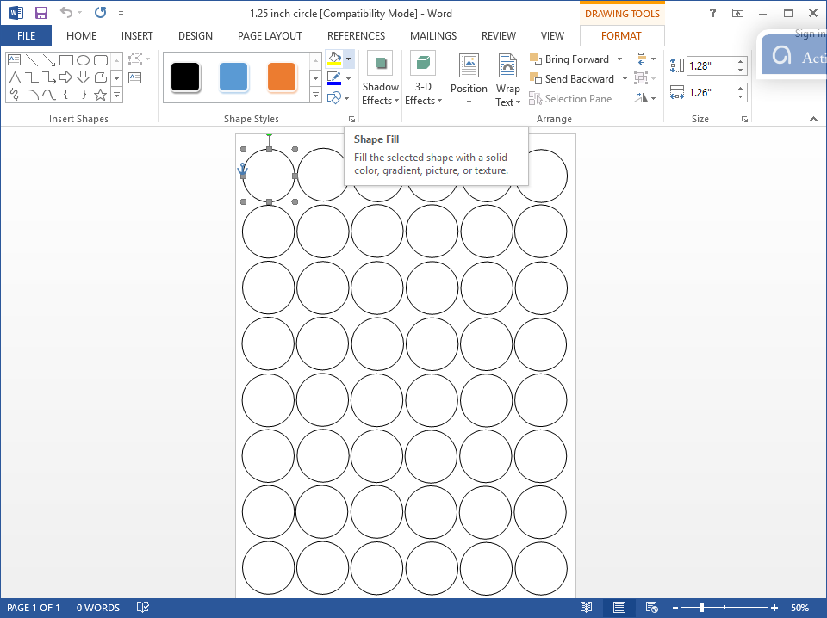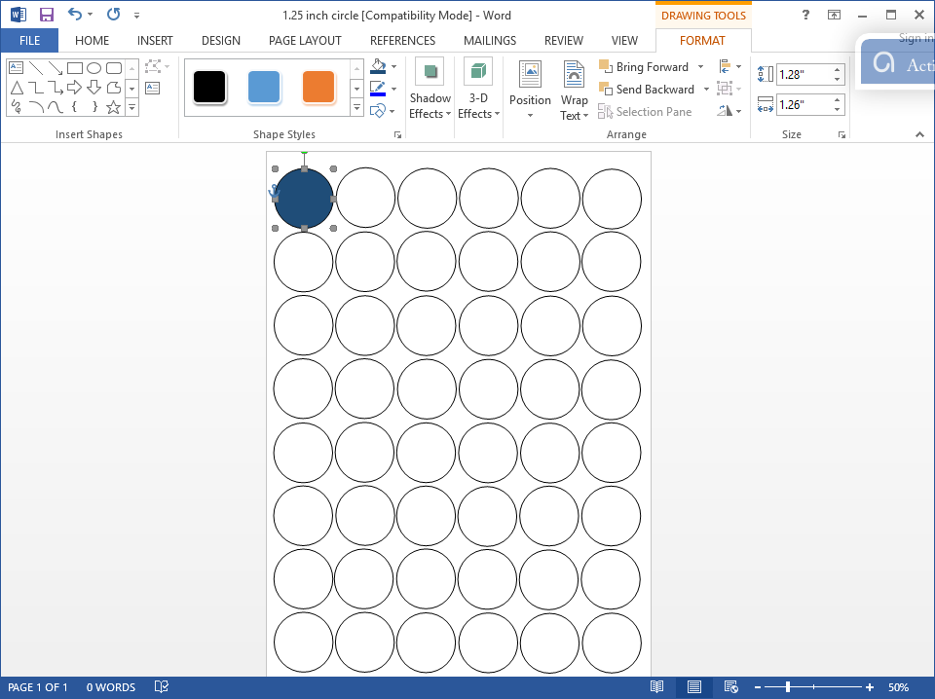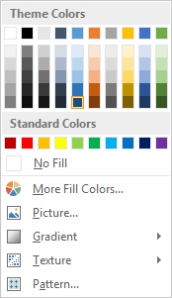

**Instructions on How to Use**

**Inkedibles**® **Premium/Artisan Frosting Sheet Circle/ Square Templates in Microsoft Word**

6. Just repeat the process for all circle objects and print.

4. Click on [Shape Fill] drop down grid button.

5. From this menu you can change the color of object or input a picture.

1. Go to [www.inkedibles.com](http://www.inkedibles.com) and lookup the item for which you need a template for. In the product description, towards the bottom, you will find a link to download the template. You can also find and download our templates via our support forum at <http://support.inkedibles.com>, search for “templates”. Now open the template in WORD and go to Step 2 below.

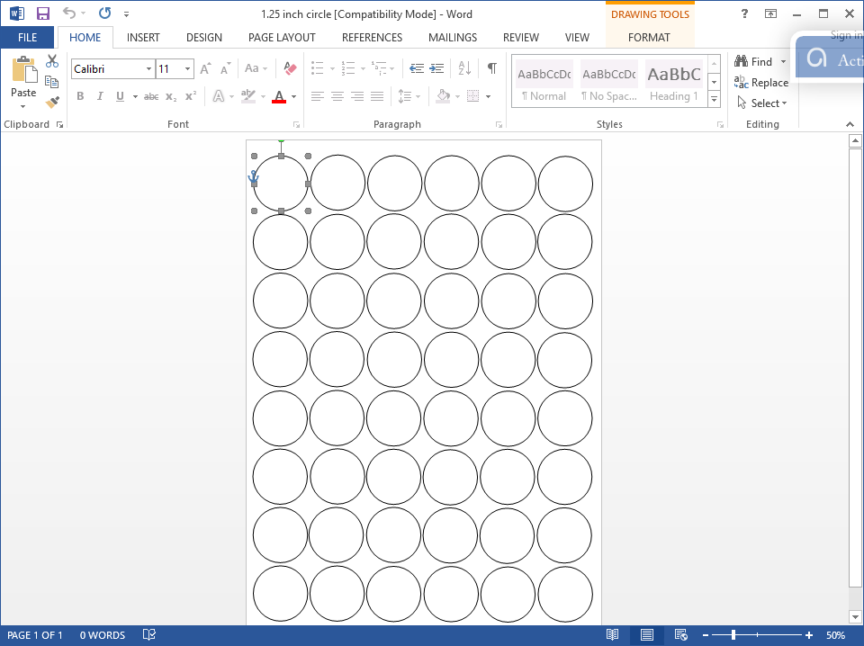

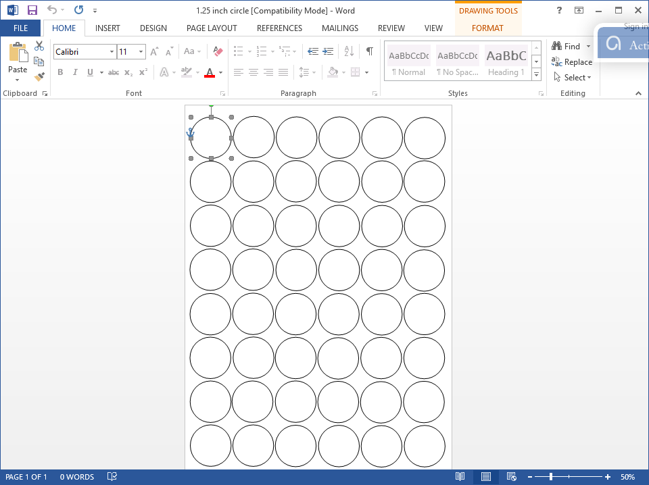

2. Click on [Circle Object]

3. Click on [Format] page tab